Canyon, Getty and Ocean Views
1201 Linda Flora Drive – Bel Air

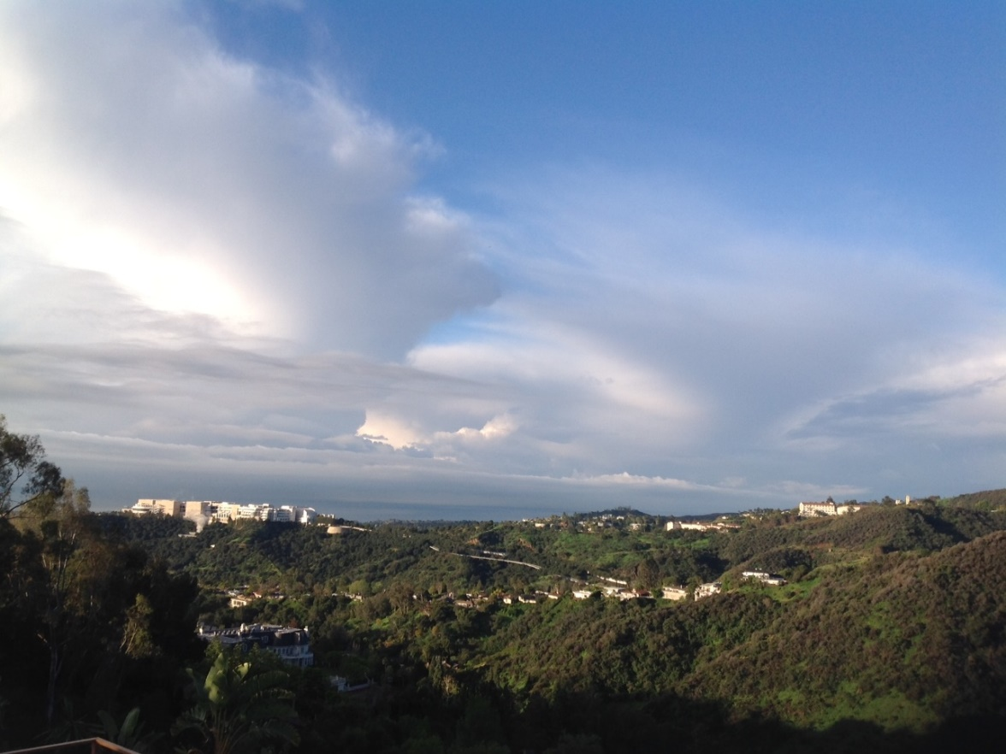 | 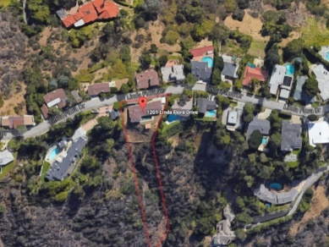
 | 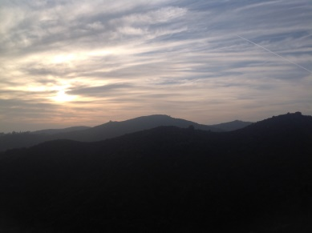
 | 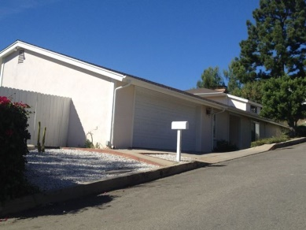

Attention Developers, Owner/Builders!
Available Immediately – Asking $2.49 Million

A GREAT DEVELOPMENT OPPORTUNITY! Developers are recognizing that this part of Bel Air offers limited opportunities to buy older, small mid-century ranches and redevelop them into 5,000 sq ft+ contemporary homes. Newer homes have recently sold for $1,200/sq ft. A visionary developer could unleash a lot value with the right project. It’s a .76 acre lot with a 2,690 sq ft 3br/3ba home, on a cul-de-sac street…133 ft of street frontage. Built in 1976. Zoned LARE20.

Don’t look back six months from now, and kick yourself for missing out while prices were still low.
Shown by appointment only. Please do not disturb the occupant.

Listed with THE BROKERAGE Real Estate Group, Drew de la Houssaye

For More Information: (Put Your Contact Info Here)

The information contained in this flyer may be unverified.
Potential buyers should take all steps necessary to confirm the accuracy of the information contained herein.

